Computer Programming
BSCS [1-A]

FINAL TERM PROJECT REPORT



Submitted By [Group No. 1]:
- Muhammad Hamza (Leader) 032
- Daniyal Jamil 024
- Abdul Moiz 002
- Aymal Ahmad 022

Submitted to: Sir Muhammad Sauood

MULTIPLAYER SNAKE GAME

DEPARTMENT OF COMPUTER SCIENCES
BAHRIA UNIVERSITY, LAHORE CAMPUS

Contents
Marks Distribution 3
Abstract 4
1. Introduction 5
2. Database Design and game mechanics 5
3.Problem Statement 6
4. Objectives 6
5. Results 6
6. Screen Shots of Final Product 7
7. References 7

TABLE OF FIGURES:
Figure 1: Initial menu ( asks for names from both players.) 6
Figure 2: SNAKE 1 MOVEMENT 7
Figure 3:Snake 2 movement 7
Figure 4: Snake collisions with wall 8

Marks Distribution
------------------------------ For Instructor Use Only ----------------------------------
Project Grading Sheet
Sr. No. | Task | Max Marks | Obtained Marks | Comments(if any)
1. | Report | 2.5
2. | Implementation | 12.5
3. | Viva  (Oral/Task Based or Both) | 5
Total |  | 20 |  | Signature:
---------------------------------------------------------------------------

Abstract
This report outlines the development of a multiplayer snake game in C++ with a console interface. Motivated by a desire to showcase programming skills and explore multiplayer game development, the project uses file handling for a dedicated game database. The challenges involve implementing a database through file handling and managing the complexities of multiplayer game play in a console environment.
The game initializes with grid size, snake positions, fruit coordinates, and player names. Functions control game flow, rendering, input, logic, and end-game processes. Gameplay involves two players controlling snakes to consume fruits and increase scores, with the game concluding at a score of 70. Results are saved in a dedicated database file.
The problem statement addresses challenges in handling user input, managing snake entities, collision detection, and scoring. Objectives include implementing a multiplayer snake game, developing logic for movement and scoring, creating an interactive console interface, and ensuring synchronized input for a seamless two-player experience.

1: Introduction

Description of the Project:
This project introduces a multiplayer snake game in C++ with a console interface, allowing two players to control separate snakes in a shared grid. Motivated by showcasing programming skills and exploring multiplayer game development in a console environment, the project utilizes file handling for a dedicated game database ("game_results.txt").

Motivation:

The project's motivation stemmed from creating an engaging and interactive game to showcase programming skills while exploring the implementation of a multiplayer gaming experience within a console environment.

Importance for Industry Practice/Knowledge Advancement:

Console-based games, though seemingly simple, provide fundamental insights into game development logic and user input handling. This project contributes to knowledge advancement by demonstrating the implementation of a multiplayer game in a resource-constrained environment.

2. Database Design and game mechanics

Database design:
There is no installed or pre-designed database connected to game, rather we have made a dedicated database for game through file handling in c++. As the game ends and one player wins or even when it’s a draw, the scores gets updates in database file “game_results.txt”. The challenge in implementing a database was it was overwriting the previous scores and adding new, working as a simple file rather than an organized database, so we overcame this issue by using <stream> library and its functions that was better for appending and modifying data.

Game Initialization:

game Over: Controls the game loop, setting to true when the game ends.

width and height: Define the grid size.

Snake positions, fruit coordinates, scores, tail arrays, movement directions, and player names.

Functions Detailed:

Functions like Setup(), Draw(), Input(), Input2(), Logic(), Logic2() manage game flow, rendering, player input, logic, and end-game processes.

Main Function Execution Flow:

Initializes, runs the loop, and executes the game loop when started by the user. Handles rendering, input, updates game state, and checks win conditions.

Gameplay Mechanics:

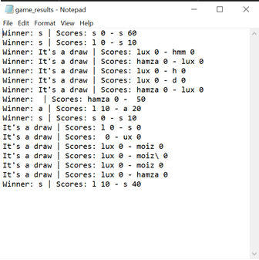
Players control snakes ('O' and 'X') aiming to consume fruits ('*') to increase scores. Game concludes when a player reaches a score of 70. Results are saved in "game_results.txt".

3: Problem Statement

Addresses implementing a multiplayer snake game in a console environment, handling user input, managing snake entities, collision detection, and scoring. Challenges involve synchronizing input, managing two snake entities, and preventing collisions.

4: Objectives
Implement a multiplayer snake game with independent control for two players.
Develop logic for snake movement, collision detection, and scoring. Create an interactive and visually appealing console interface.
Ensure synchronized input for a seamless two-player gaming experience.

5: Results

- Utilizes C++ concepts such as arrays, randomization, and conditional statements.
- Captures user input using _kbhit() and GetAsyncKeyState() for Player 1 and Player 2.
- Game logic updates snake positions, tail arrays, checks collisions, and manages scoring.

6: Screen Shots of Final Product

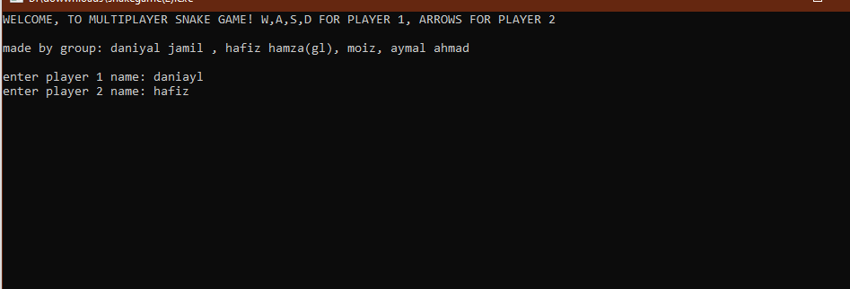
Figure 1: Initial menu ( asks for names from both players.)
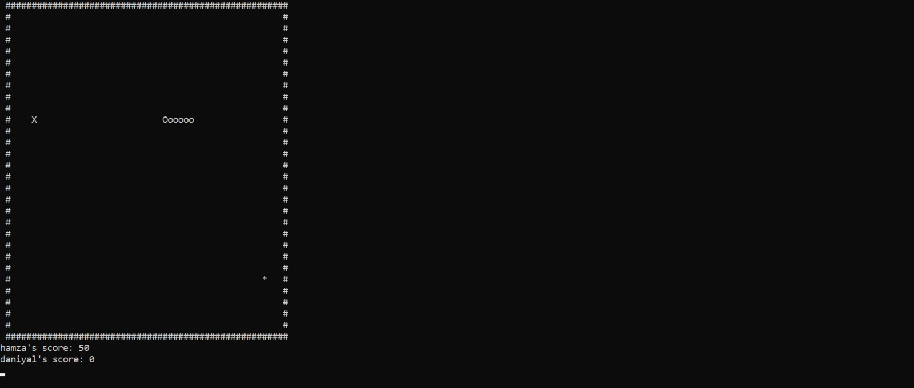
Figure 2: SNAKE 1 MOVEMENT

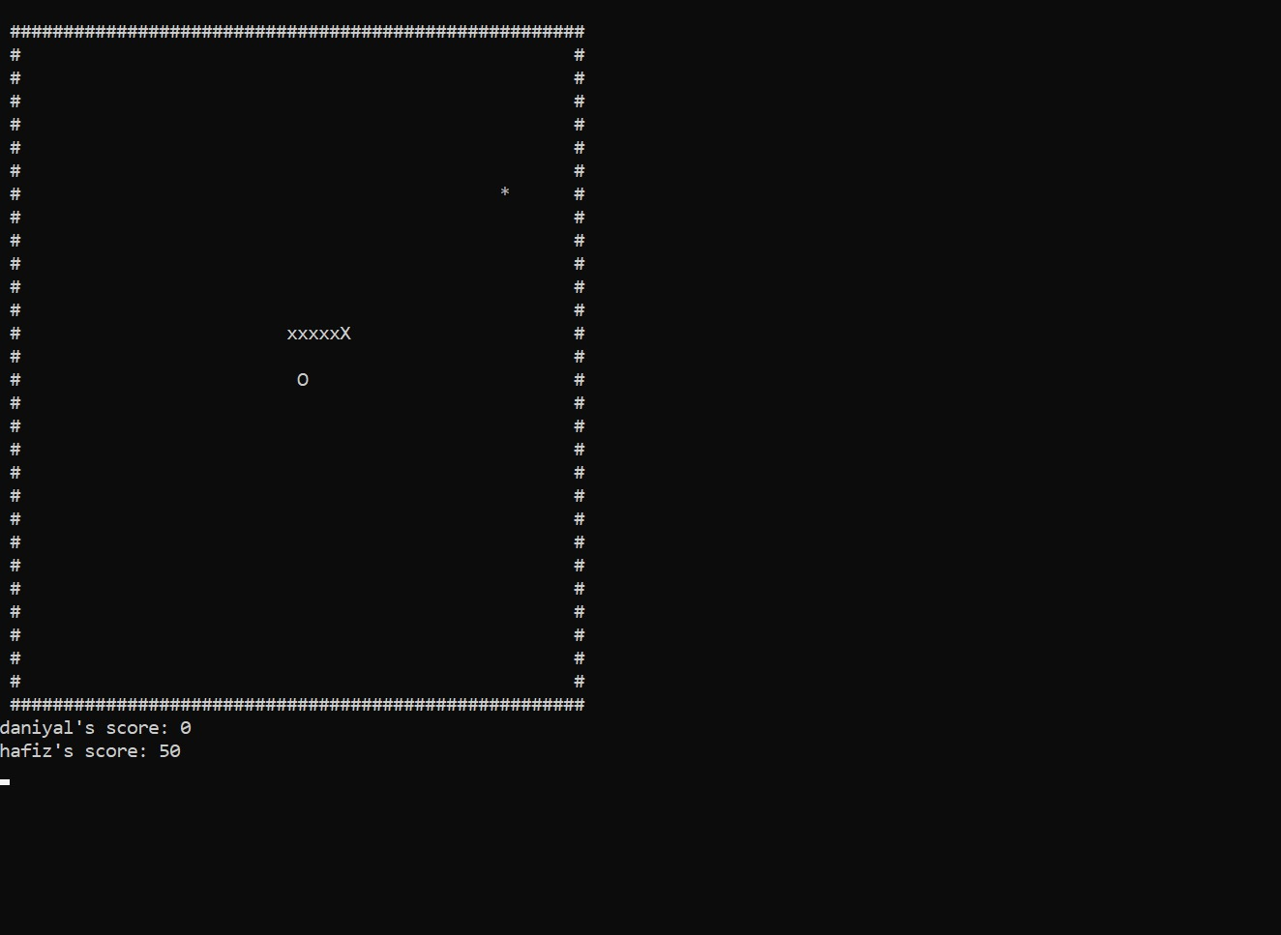
Figure 3:Snake 2 movement
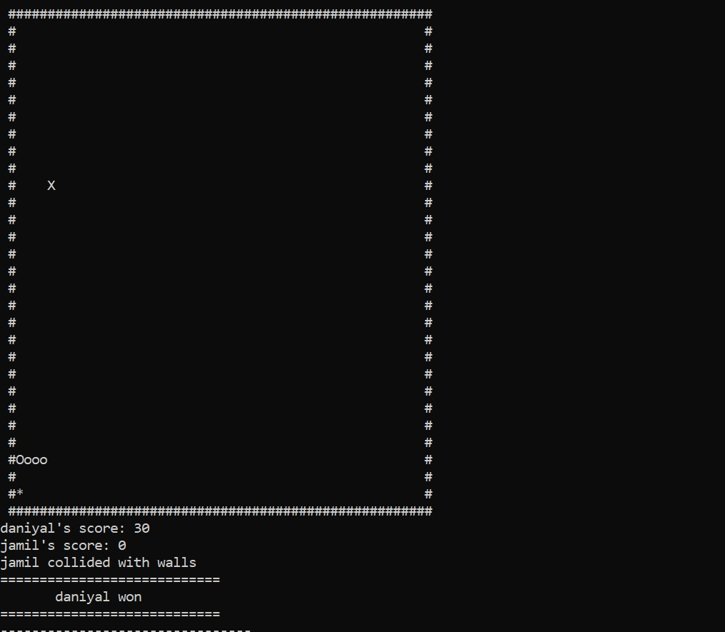
Figure 4: Snake collisions with wall
Figure 6: Data base end results.

7:References
Multiplayer concept is original ( hence, no reference)
1.YouTube video followed for base game idea.
https://youtu.be/E_-lMZDi7Uw?si=4lkAuUqg4tQKXDAq

2.Website used for code reference and library guidance:
https://hackthedeveloper.com/snake-game-cpp/

3.Youtube video used to understand how file handling works:
https://youtu.be/6BhH2FPfS30?si=f9FPc4mwRajRvxdW
4.Chat GPT used to understand how movement might work.

